DP STRING PROBLEMS
1.dna sequence comparison
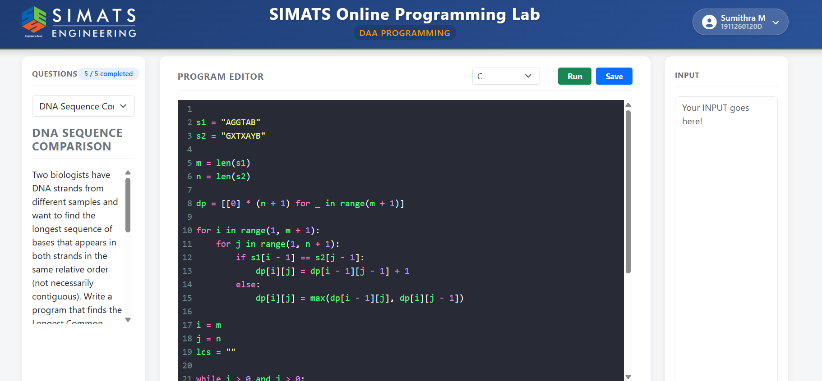
2.spellchecker edit distance
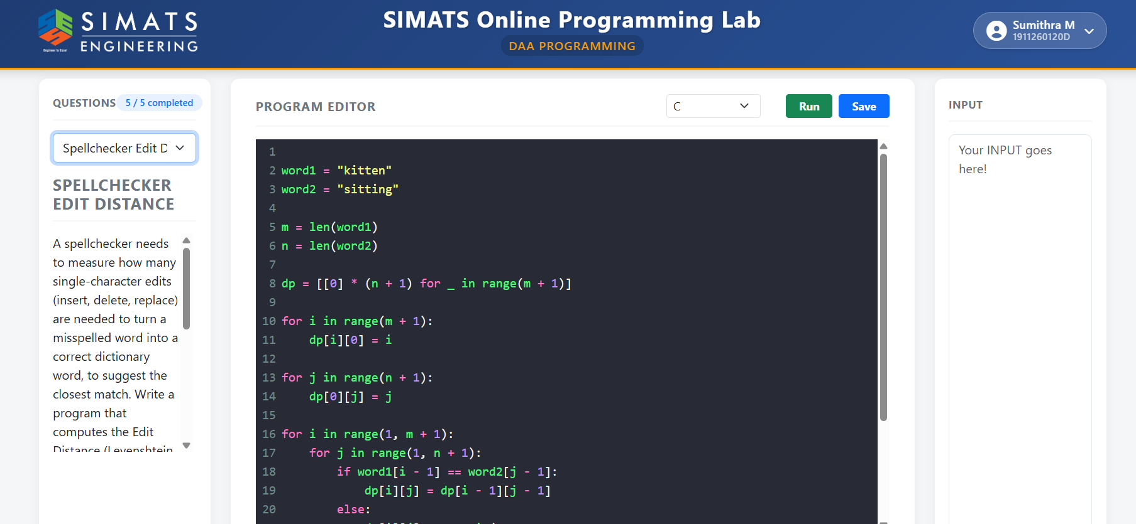
3.longest palindrome finder
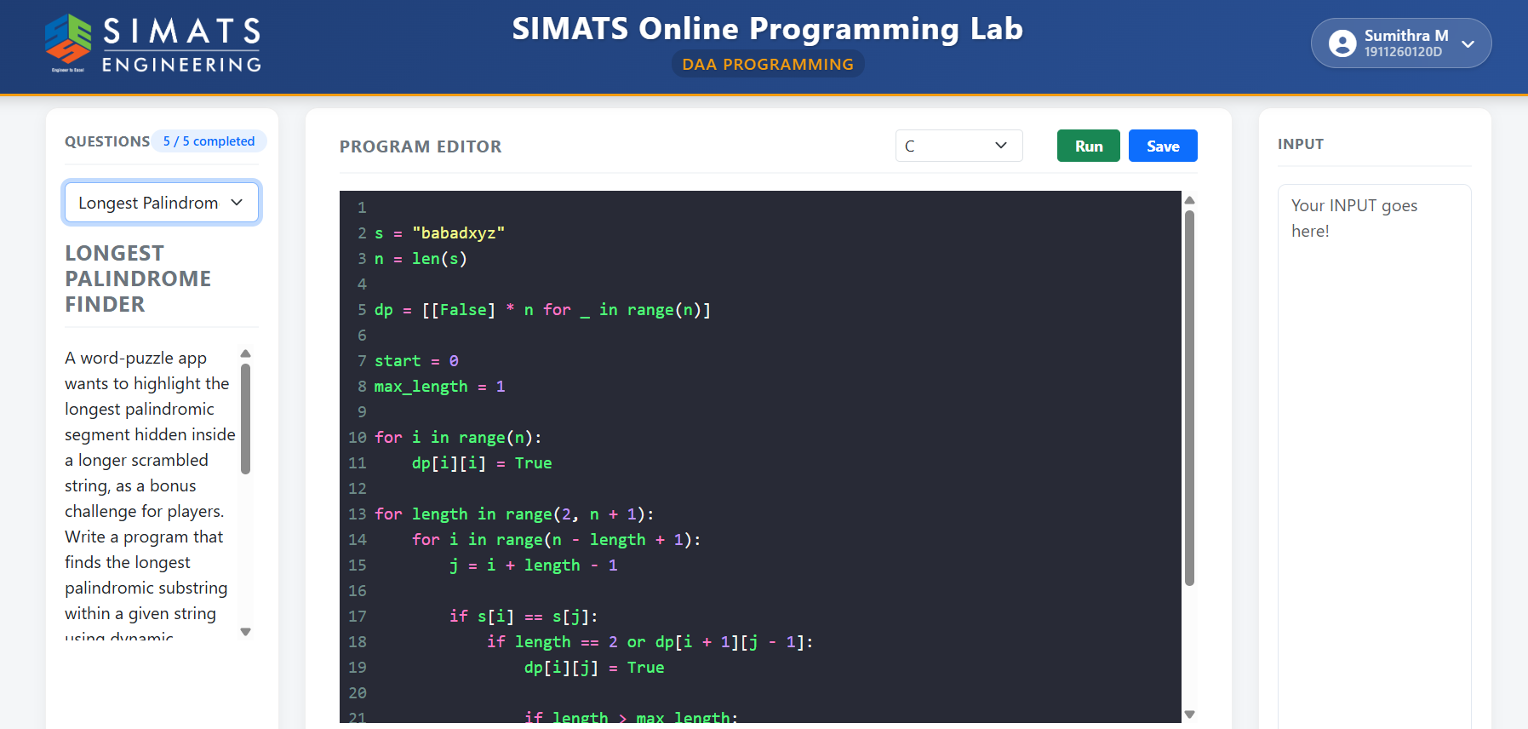
4.minimum palindrome cuts
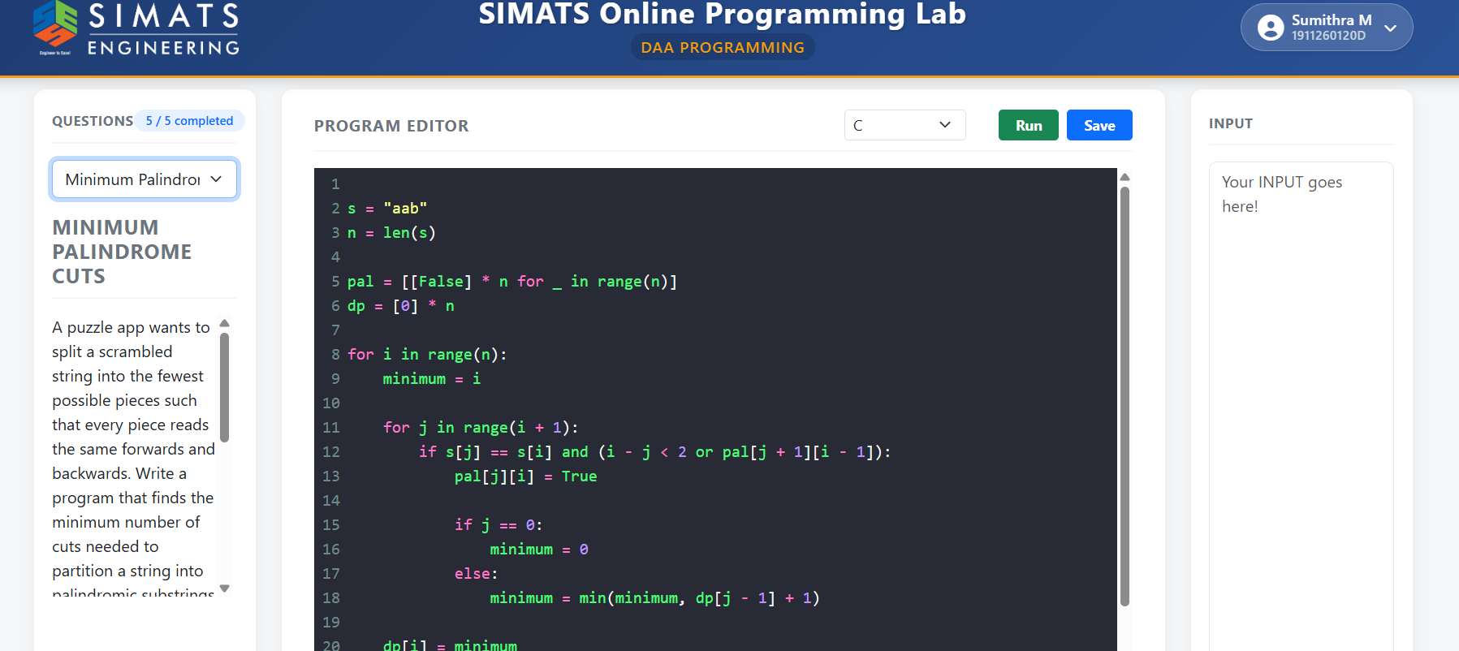
5.plagiarism substring match


